**Laplace Transform**

[[Kamil Budagov](https://medium.com/@kamil2000budaqov?source=post_page-----5e61cc2363f4--------------------------------)](https://medium.com/@kamil2000budaqov?source=post_page-----5e61cc2363f4--------------------------------)

[Kamil Budagov](https://medium.com/@kamil2000budaqov?source=post_page-----5e61cc2363f4--------------------------------)

·

[Follow](https://medium.com/m/signin?actionUrl=https%3A%2F%2Fmedium.com%2F_%2Fsubscribe%2Fuser%2F74baf91e26f&operation=register&redirect=https%3A%2F%2Fmedium.com%2F%40kamil2000budaqov%2Flaplace-transform-5e61cc2363f4&user=Kamil+Budagov&userId=74baf91e26f&source=post_page-74baf91e26f----5e61cc2363f4---------------------post_header-----------)

12 min read

·

Aug 26

21

**Introduction**

We will delve deeply into one of the most important mathematical tools, the Laplace transform, in this story. When solving differential equations or systems of differential equations, figuring out the frequency content of time domain signals, determining the stability, controllability, and observability of systems, etc., it is frequently used. A number of examples of real-world issues will be resolved using the Laplace transform. We will begin by defining signals and systems before arriving at the crucial connection between the LTI system’s input and output. The convolution theorem will then be demonstrated. Finally, we’ll introduce the Laplace transform and describe its characteristics. The Laplace transform will be used to solve several problems pertinent to electricity, mechanics, and thermodynamics.

**Continuous Signals and LTI Systems**

Signals whose values vary continuously with time are considered continuous signals. Examples of continuous signals are temperature of ambient air, level of liquid in a tank, speed of a car, etc. Systems that produce continuous output in response to continuous input are referred to as continuous systems. A spring-mass system and an electrical circuit are typical examples of continuous systems.

In this paper, we will focus on Linear Time-Invariant (LTI) systems, where linearity implies that superposition is met. We can explain superposition simply as follows:

*If the output of a system for inputs****x_1(t)****and****x_2(t)****is****y_1(t)****and****y_2(t)****, respectively, then the output for the input****ax_1(t)+b x_2(t)****will be****ay_1(t)+by_2(t)****, where a and b are constant real numbers. (Fig 1.1)*

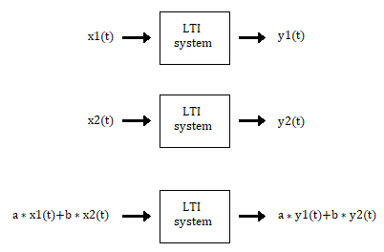

Figure 1.1

Time invariance is another important characteristic of the LTI system, asserting that “when the input is delayed by a certain duration, the output will also experience an equivalent delay”. This principle can be expressed graphically in the following diagram: (Fig 1.2)

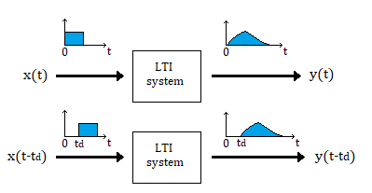

Figure 1.2

**Convolution Integral**

It is important to understand the relationship between an input to the system and the output produced. Actually, there is a very simple relationship between input and corresponding output, which we call the convolution integral. In this section, we will derive the convolution integral by exploiting the linearity and time-invariance properties of the LTI system.

Let us start by defining a function **w(t)** (That will help us approximate our input**x(t)**) which has the following graph:

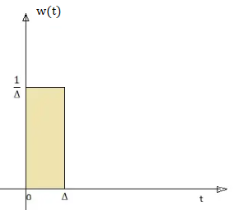

Figure 2.1

The value of **w(t)** is equal to **1/ ∆** when **0 ≤ t <∆** and zero otherwise. As it seems from the graph, the area under **w(t)** is always equal to one independent of **∆**.

By shifting the shaded rectangle in Fig 2.1 to the right, we can graph **w(t-∆)** as follows:

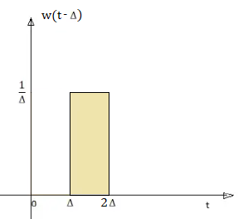

Figure 2.2

Since **w(t-k∆)∆**is always equal to one, we can reconstruct **x(t)** as in the following diagram:

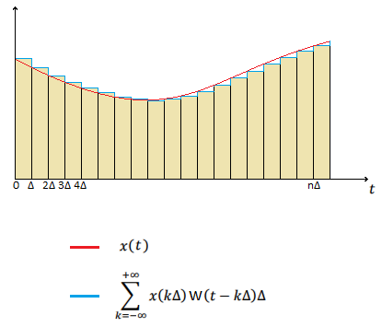

Figure 2.3

The value of summation for **𝑘∆≤t<(𝑘+1)∆** is equal to **x(t)** evaluated at **t=𝑘∆**. Therefore, we can justify the following approximation for **x(t)**.



Our approximation will get more precise as **∆** becomes smaller, and the limit of this sum as **∆** approaches zero will be an exact reconstruction of **𝑥(𝑡)**, which is integral by definition:



Equation 2.1

* ***Note 1****: As****∆****approaches zero,****k∆****becomes a continuous variable as the gap between****k∆****and****(k+1)∆****also approaches zero. Therefore,****k∆****is denoted by the continuous variable****τ****and****∆****turns to****dτ****. Since****dτ****is infinitesimal, the value of****w****at****t=τ****will be infinite from the definition (****1/dτ****) of****w****. Actually, for****∆=dτ****,****w(t)****behaves like the famous****Dirac Delta function δ(t)****. Therefore, we change the symbol****w****to****δ****to show that it is actually the Dirac Delta function when****∆****is infinitesimal.*

Equation 2.1 implies that any continuous-time signal **𝑥(𝑡)** can be shown as the sum of shifted and scaled impulses. Therefore, if we know the response of the system for a single impulse (**impulse response**), then we can calculate the response of the system for any input since our system is linear and time-invariant.

The following diagram depicts how the linearity and time-invariance properties of the LTI system help us derive the equation for the output of the system, which is a convolution operation between the input **x(t)** and the impulse response **h(t)**:

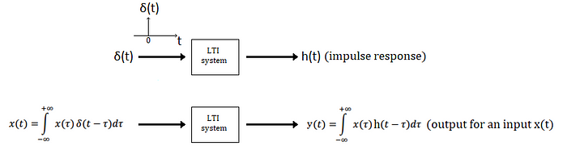

Figure 2.4

The convolution operation is shortly denoted as follows:

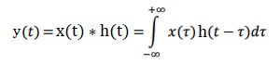

Equation 2.2

We can easily demonstrate the commutativity of convolution as depicted by by the following equation:



Just by replacing **t-τ** with **k** , (**k=t-τ** or **τ=t-k)**we can rewrite **x(t)*h(t)** as follows:

* ***Note 2****: Since****τ****ranges from****-∞ to +∞****,****k****extend from****+∞ to -∞****for any finite value of****t****. Furthermore, since the variation in****τ****does not affect****t****, differential****dk****corresponds to**differential****-dτ****.*

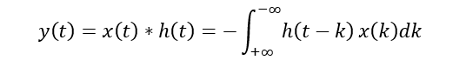

We can actually rewrite the above formula as follows by reversing the limits of the integral, whereby the minus sign is cancelled:

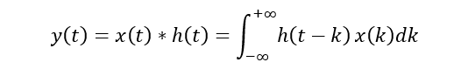

Equation 2.3

Equation 2.3 is a proof of the commutative property of a convolution operation.

***Example:***Assume that our input to the system is **x(t)=exp(-0.7t)u(t)** and the system has an impulse response **h(t)=exp(-2t)u(t)**. Let’s determine the output of the system.*(****u(t)****is the step function, which is equal to zero for t≤0 and one for t>0).*

According to Equation 2.2, we can show the output of the system as follows:

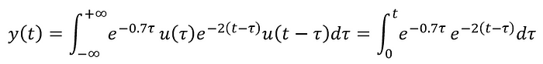

* ***Note 3****: Since****u(τ)=0****for****τ≤0****, the integral’s lower bound will be 0. Additionally, for a specific time t, which is a finite number,****u(t-τ)=0****for****τ≥t****. Therefore, the integral’s upper bound reduces to t from +∞. To sum up, we can update the limits of the above integral by eliminating the unit-step functions.*

Finally, we can determine the output of the system by solving the following integral:

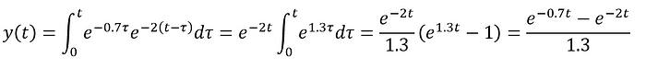

As it seems from the following diagram, the output value at time t is equal to the integral of the product of two functions indicated by red and blue colors. Notice that product is zero out of the range 0<τ<t, which lets us modify the limits for the integral as explained in note 3. Therefore, the value of y(t) will also be zero for t≤0.

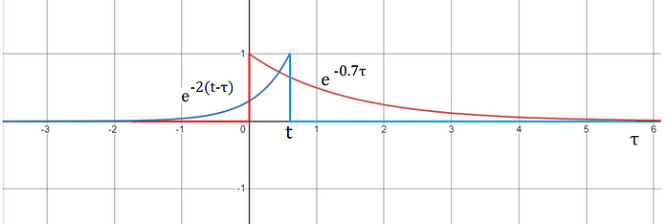

**Laplace Transform**

The Laplace transform of function **f(t)** is denoted by **F(s),** which is calculated as follows:

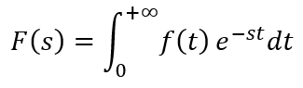

where **s** is a complex variable:



The Laplace transform is commonly associated with real-world signals that are nonzero only for positive values of time. With this in mind, taking the Laplace transform of **f(t)**which is zero for t≤0, is equivalent to taking the [Fourier transform](https://medium.com/@kamil2000budaqov/fourier-series-fourier-transform-ae748fcd424a) of **f(t)exp(-σt)**.

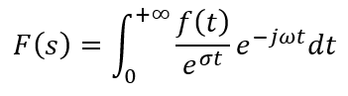

Depending on the function **f(t)**, Laplace transform will only converge for some values of **s**. The region in the complex **s** plane for which the Laplace transform converges is called the region of convergence, or ROC. Keep in mind that the limit of **f(t)exp(-σt)**as **t** approaches +infinity must approach zero to ensure convergence of the Laplace transform of **f(t)**. This condition is necessary to ensure the integral remains bound and convergence is achieved. Without this, the integral would not converge. Now let us consider one example regarding the calculation of the Laplace transform and determining its corresponding ROC.

***Example****:* Let us calculate the Laplace transform of **f(t)=exp(-2t)u(t)**.

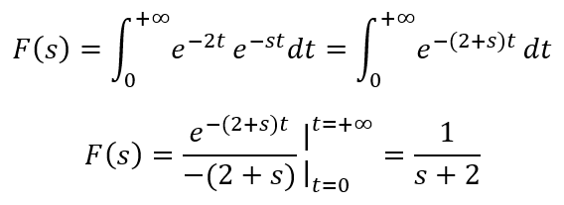

Since **s** is a complex variable, **s=σ+jω**, we can rewrite the formula as follows:

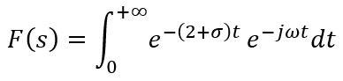

Because the second exponential is pure oscillation with real and imaginary parts, the Laplace transform (Real and Imaginary parts of the Laplace transform) will only converge for positive values of **2+σ** or **σ>-2**.

* ***Note 4:****At σ=-2, an area calculated by Laplace transform does not converge since we integrate pure oscillation****exp(-jωt)****from****t = 0 to t=+∞****.*

Therefore, the ROC for this example is the shaded area of the following plane:

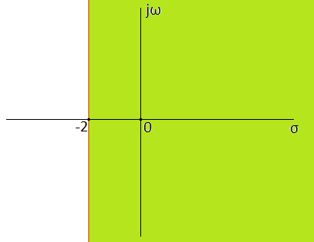

[Here you can find the Laplace Transform table for common signals.](https://cdn.numerade.com/ask_images/80e55573d70f422ebc377875b3ac2668.jpg?_gl=1*gj44fr*_ga*Mzc1MjY4NDE4LjE2OTEwNzA2MDg.*_ga_K0NSFP2V8T*MTY5MTA3MDYwOC4xLjEuMTY5MTA3MDcyNS41OS4wLjA.) Take into account that all functions in the table are zero for t≤0.

**Convolution Theorem**

Let’s now arrive at the Laplace transform’s most crucial property, which states that the Laplace transform of the convolution of two functions equals the product of their individual Laplace transforms; in other words, if **y(t)=x(t)*h(t)**, then **Y(s)=X(s)H(s)**. We assume that both functions **x(t)**and**h(t)** are zero for t≤0. Therefore, we can show them as **x(t)u(t)** and **h(t)u(t)**.

We start with the definition of convolution. Through the elimination of the step function **u(τ)**, we can modify the lower limit of the integral as shown below:

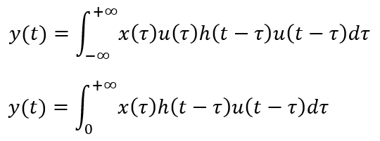

Now let us put **y(t)** into the Laplace Transform formula:

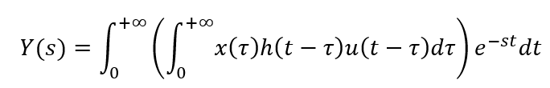

By arranging the terms, we get:

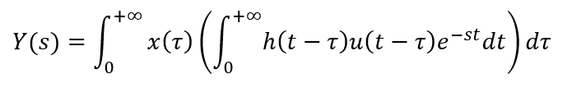

Moving forward, let’s proceed with the computation of the inner integral, which includes the following steps:

First, we substitute**t-τ** with the variable **v (v= t-τ)**. Since **τ** is a constant with respect to the inner integral, the differential **dv** corresponds to **dt**. Given that **t** varies from **0** to **+∞**, **v (v= t-τ)** ranges from **-τ** to **+∞**. Furthermore, considering the outer integral, **τ** ranges from **0** to **+∞**. Consequently, we can update the lower limit of the integral to zero by eliminating **u(v)**. Furthermore, we can extract **exp(-sτ)** from the integral as it is not affected by variations in **v**:

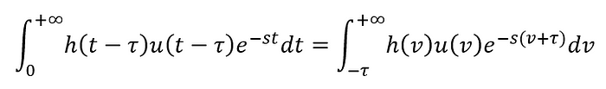

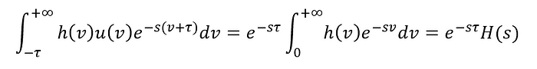

By substituting this result to the main formula for the Laplace transform of **y(t)**, we get the product of the Laplace Transforms **H(s)** and **X(s)**.

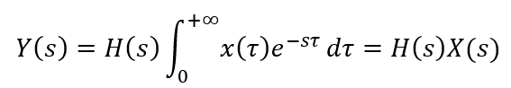

**Laplace Transform of first derivative**

Now let us calculate the Laplace transform of the derivative of **f(t)**:

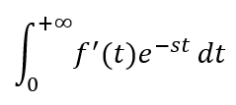

First, let me remind you of the product rule for derivatives demonstrated in the equation below:

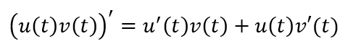

By integrating both sides from**t = a to t = b**, we get:

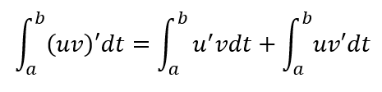

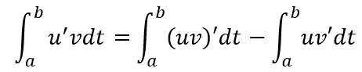

We can calculate the Laplace transform of the derivative according to the above formula by denoting **f(t)**and **exp(-st)**by**u** and **v**, respectively**:**

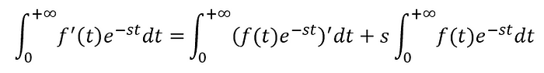

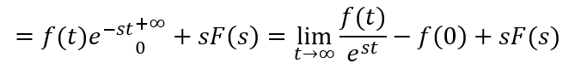

As we mentioned before, **s** must be in the Region of Convergence (ROC) to ensure convergence of the Laplace Transform of **f(t)**. Actually, the ROC encompasses the region in which the above limit is equal to zero. Therefore, the Laplace transform of the derivative of f(t) is expressed as follows:

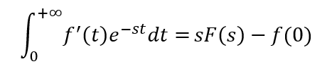

**Laplace Transform of second derivative**

Knowing the Laplace Transform of the first derivative, we can easily obtain a formula for the second derivative as follows: (Replace **f’(t)** with **g(t)**)



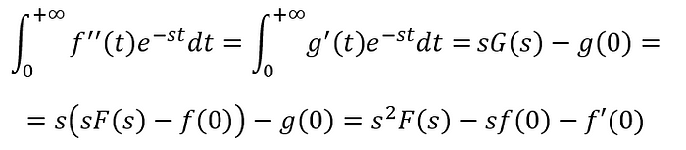

**Laplace Transform in Practice**

***Example 1:***The circuit depicted below is stimulated by the unit impulse function u(t). Consider that the initial current and voltage drops across all components are zero. Our objective is to compute both the voltage across the capacitor and the current circulating within the circuit.

**Step 1:** The Kirchoff’s voltage rule and the relationships between current and voltage drops across various electrical components are written down in the first step. Next, we only use the potential difference across the capacitor to express Kirchoff’s voltage rule.

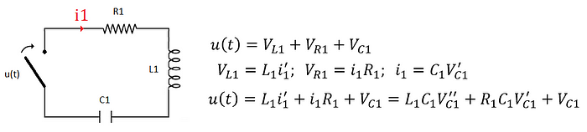

**Step 2:**Next, we perform the Laplace transform on both sides of the equation.

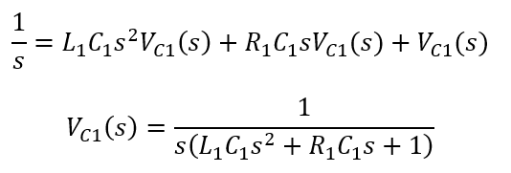

**Step 3:**By inputting the following values into the formula above, we get V_C1(s) expressed in terms of variable s. Partial fraction decomposition is then applied to rewrite V_C1(s). Finally, we use [the Laplace transform table](https://cdn.numerade.com/ask_images/80e55573d70f422ebc377875b3ac2668.jpg?_gl=1*gj44fr*_ga*Mzc1MjY4NDE4LjE2OTEwNzA2MDg.*_ga_K0NSFP2V8T*MTY5MTA3MDYwOC4xLjEuMTY5MTA3MDcyNS41OS4wLjA.) to retrieve the signal in the time-domain from V_C1(s).

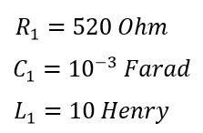

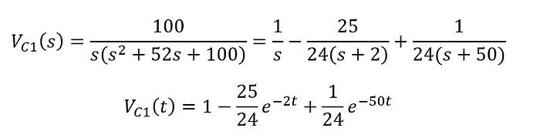

Moreover, we can determine the current in the circuit as follows:

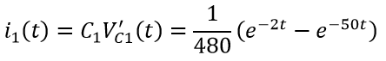

***Example 2:***The system is initially in a state of rest, and a sudden application of F(t) = u(t) occurs. Let’s observe the evolution of the position and velocity of the mass over time.

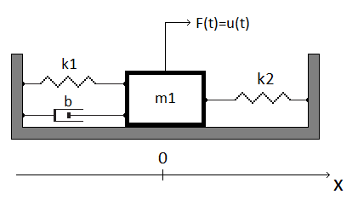

**Step 1:**We start by writing down Newton’s second law for mass:



**Step 2:**The Laplace transform is applied to the equation of the motion, leading to simplification while considering the zero initial conditions (both position and velocity):



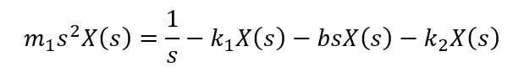

**Step 3:**By substituting the following values into the equation above, we first express X(s) in terms of s, followed by partial fraction decomposition. Finally, the inverse of X(s) gives us the precise position of the mass. Moreover, the velocity can be determined by differentiating the position.

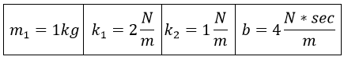

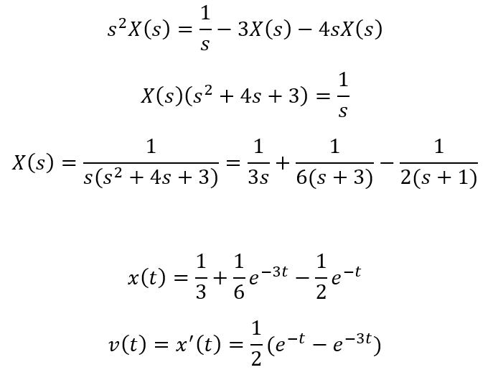

***Example 3:***The first wall has a cooling coefficient denoted as k_1, while the second wall has k_2. The initial temperature is uniformly set to zero. Suddenly, an external input of 10 degrees Celsius is imposed outside the first wall. Now, let’s observe the evolution of temperatures, T_1(t) and T_2(t), over time.

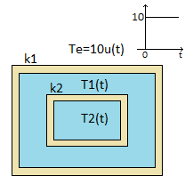

**Step 1:**Write down the equations representing Newton’s cooling law for T_1 and T_2.

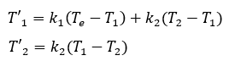

**Step 2:**Apply the Laplace transformation to the system of differential equations provided earlier. As it seems, the application of the Laplace transform transforms the system of differential equations into a system of algebraic equations, making it an incredibly powerful method for resolving intricate systems of differential equations.

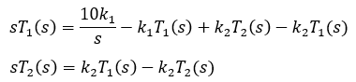

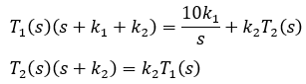

**Step 3:**In this step, we find T_2(s) using the second equation and then insert it into the first equation in order to express T_1(s) in terms of variable s:

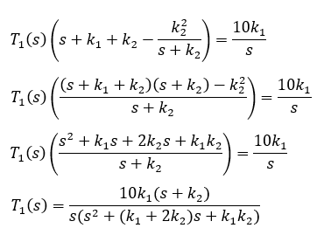

**Step 4:**Subsequently, the cooling constants k_1 and k_2 are inputted into T_1(s), followed by partial fraction decomposition. Next, the representation of T_2(s) in terms of s is established, and a similar approach is applied to decompose it. Finally, we recover signals in the time domain from T_1(s) and T_2(s).

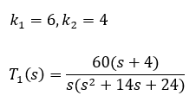

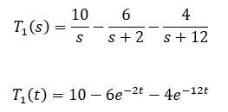

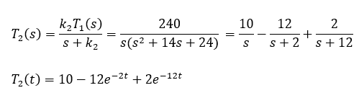

**Conclusion**

In conclusion, delving into the realm of the Laplace transform and its application to Linear Time-Invariant (LTI) systems has been an enlightening journey. From the fundamental definition of LTI systems to the intricacies of the convolution integral, we’ve witnessed the elegant way in which these mathematical concepts come together to unravel the behavior of dynamic systems.

Through practical examples, we’ve seen the Laplace transform in action — how it can unveil the secrets of circuits, vibrations, and beyond. Its transformative power has not only provided solutions to ordinary differential equations but has also offered insights into the very essence of how nature responds to various inputs.